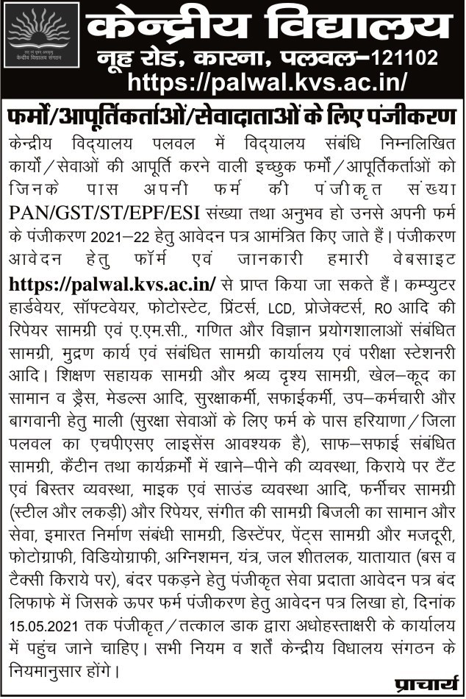

केन्‍द्रीय विद्यालय पलवल
लेखा संहिता के आर्टिकल 170 (संशोधित के तहत वर्ष 2021-22 हेतु फर्मों का पंजीकरण
Enlistment of firms under Article 170 (Revised) of Accounts Code
(Use Separate form for each service registration)
Note:
(a) filled up forms must be submitted to the Principal, K.V., Palwal for enlistment of Firms/Proprietors’/ Contractors / Suppliers / Manufacturer under Article 170 (Revised) Accounts Code.
(b) Incomplete forms without required enclosures will be rejected without intimation.
1. | फर्म का नाम  Name of the Firm
2. | फर्म का पता पिन कोड सहित  Address of the Firm with pin code
3. | मालिक/ साझेदार का नाम  Name of the Proprietor/ Partner
4. | फर्म के पंजीकरण क्रमांक/ व्यापार लाइसेंस प्रमाण पत्र (छायाप्रति संलग्न करे)  Firm Registration Number/ Trade License Certificate (Enclose a Xerox copy)
5. | आयकर/ पेनकार्ड क्रमांक (छायाप्रति संलग्न करे)  Income Tax/Pan Card No. (Enclose a Xerox copy)
6. | GST पंजीकरण प्रमाण (छायाप्रति संलग्न करे)  GST Registration Certificate (Enclose a Xerox copy)
7. | /सी. एस. टी. प्रमाण पत्र / सर्विस टैक्सपंजीकरण क्रमांक (छायाप्रति संलग्न करे)  CST Certificate/Service Tax Reg. No. (Enclose a Xerox copy)
8. | संपर्क संख्या  Contact No. (Both Landline & Mobile)
9. | ई-मेल पता  E-Mail Address:
10. | फर्म द्वारा दी जा रही सेवा/उत्पाद का विविरण जिस हेतु पंजीकरण करवाया जा रहा है | (विशेष योग्यता यदि कोई हो)  Details of Services being provided by the firm to get registration (specialisation if any) | - ……………………………………..  - ……………………………………..  - ……………………………………..  - ……………………………………..  5- ……………………………………..
11. | Experience(if any)
उद् घोषणा
UNDERTAKING
I, Mr.…………………………………………………………..Proprietor/Partner of M/s ………… …… ……… ………… …………… …………… do hereby certify that the above furnished information is correct. In case of any information found to be incorrect, I understand that the offer of contract will be cancelled and action will be initiated as per KVS rules. I assure to provide best services/articles as possible to K.V. Palwal
स्थान:.............................  Place : ………………………………..  दिनांक:.........................  Date : ……………………………….. |  | मालिक / साझेदार के हस्ताक्षर एवं फर्म की मोहर  Signature of the Proprietor/ Partner with office stamp and seal

